Week 4 Readings
Please complete the followings readings by:
- Read all online lectures for Week 4.
- Read following chapters from the 3ds Max 2010 Bible
  - Using the Material Editor and the Material Explorer
  - Adding Material Details with Maps
  - Unwrapping UV’s and Mapping Textures
Practice Exercises:
Complete the following short tutorial lessons from the 3ds Max 2010 Bible:
- Exploring the Max Interface:
  - Making curtains Translucent
  - Coloring a Dolphin
- Adding Material Details with Maps:
  - Creating a mirrored surface
  - Aging objects for realism
- Unwrapping UVs and Mapping Textures:
  - Using the UVW Map modifier to apply decals
  - Controlling the mapping of a covered wagon
  - Creating mapping for a fighter plane
  - Spline Mapping a snake
  - Using Pelt Mapping
Week 4 Assignments Overview
Assignment Summary Week 4: | Due Date
Assignment 1: Practice Exercise | Tuesday, February 2, 2010
Assignment 2: Final Project - Creating and Applying Materials | Thursday, February 4, 2010
Assignment 3: Final Project - Creating and Applying Material Maps | Saturday, February 6, 2010
Using the navigation on the left, please proceed to the next page.

Week 4 Overview
Congratulations on completing three weeks of this course! You are now halfway on creating your 3D scene. Through the last few weeks, you have modeled your interior scene. This week, you will continue adding the textures or the colors on the objects that create your scene. Let’s begin.

Learning Outcomes
Create and apply materials to the model to define its color and texture.

The Truth About Surfaces
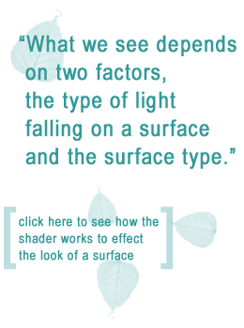
This week we move into an entirely different aspect of 3D scene creation. You will define surfaces for the 3D models created in the past few weeks. Defining surfaces for 3D models is similar to painting a door to give it the final look after building it by cutting, sawing, and fixing pieces of wood. Without appropriate surfaces it's difficult to differentiate between the 3D models of a football, a tennis ball, or a golf ball.
Defining the surfaces of 3D models involves creating materials and assigning these materials to the 3D models in a scene. But before you start creating materials in 3ds Max you need to know how various surfaces behave when light falls on them. This is because 3ds Max uses the principles of light and optics to render materials for 3D models.

How do we See Surfaces?
What we see depends on two factors, the type of light falling on a surface and the surface type. We will study about the types of light next week. This week we'll concentrate on learning about the types of surfaces and how can you define them in 3ds Max.
When light falls on a surface, some light is absorbed or transmitted by the surface, and the rest is bounced back. Light that bounces back enters our eyes, and our brain interprets the color, shape, roughness, shine, and transparency of the surface.
The attributes of a surface govern the amount and angle of light bounced back by the surface. Therefore understanding surface attributes is essential before defining them in 3ds Max.
Explore:
Making Convincing Reflective Shaders in 3DS Max 7.5 and up using the Mental Ray Render

http://www.3dm3.com/tutorials/shaders/

Observing Surfaces Closely
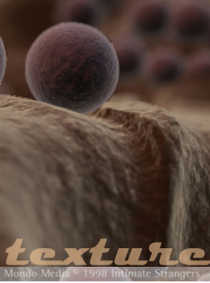
Observing various surfaces is the best method of understanding their attributes. Look closely at a surface near you. Avoid observing a curved surface at this stage. Choose a flat surface. For example you can observe the top of a wooden table. What color is it made of? Your first answer will be brown. But if you apply brown color on a box primitive in 3D, will it look like a wooden tabletop? The answer is "No." There is much more than just the brown color that makes a box primitive look like a tabletop.
Some important attributes of surfaces are:
- Color
- Texture
- Roughness
- Shine
- Transparency
- Reflection
Let's look at each of these attributes and how you can specify these attributes in 3ds Max.

Color
The basic color of an object has the biggest impact on the final color of the object that we see, regardless of its shine, the color of light falling on it, or the shadows it's receiving. It's the color of the object that we generally refer to when we describe the object's surface. For example the basic color of a wooden table is brown.
In 3ds Max the basic color of an object is called the diffuse color. When you define the surface of a 3D model, it's the diffuse color that you specify first. For example when defining the surface of a golden ring, you would first specify the diffuse color as dark yellow.

Texture
Not all objects are made of solid colors. Most objects have patterns on them. For example printed clothes have several patterns on them; a fish has a pattern of scales on it, and a piece of wood has a pattern of grains on it. The pattern of specific colors on an object defines the texture of that object.
In 3ds Max you can specify the texture of a 3D model by adding a map to the material created for that model. We will learn about adding maps to a material later this week.

Roughness
The surface of an object is rough because the surface is uneven. In 3ds max 3D models have smooth surfaces by default. Therefore when the models are rendered, they don't look realistic. Making the surface of a 3D model uneven is a tedious process. Instead you can define the bump parameters in the material of the 3D model to create an effect of roughness. For example you can enhance a model of a towel by specifying the bump parameters of its material.

Shine
If you look closely at a shiny surface, you'll find some areas shine more than the others. Shine is generated because some areas of a surface reflect more light than other areas. In general curved surfaces shine more than flat surfaces. For example the curves of a sports car produce more shine than the flat surface of the car.
In 3ds Max the Specular Level and Glossiness parameters of a material control the shine of the material. The Specular Level parameter defines the intensity of shine, and the Glossiness parameter defines the extent of shine.

Transparency
Transparent objects let light pass through them. However, even transparent objects reflect some amount of light. For example on a sunny afternoon if you stand outside a room with glazed windows and look through the window pane, you will see your own reflection.
You can define the transparency of a material in 3ds Max. The level of transparency for a material should be decided after careful consideration. To make the glass material for the window mentioned in the previous example, you need to set its transparency to about 60%. Setting inappropriate transparency parameters produces unrealistic materials.

Reflection
Flat surfaces distort reflected light rays less than curved surfaces. You need to observe and analyze reflection by different surfaces before creating reflective surfaces in 3ds Max. You can start by sketching reflected images formed by a curved surface such as a metal spoon.
While observing surfaces to analyze their appearance, take into account each of the above-mentioned attributes of a surface. In addition you can sketch the surfaces that you observe to understand their attributes better. This will help you specify the corresponding parameters of the materials that you create in 3ds Max.
3ds Max provides you with a lot of flexibility in defining all the attributes of a surface that you perceive. It is up to you to maintain a balance between the attributes that you define depending on you requirement. If the balance is not maintained, the surfaces produced are not believable. Carefully observing surfaces in the world and analyzing their attributes will help you maintain this balance.

Making Materials for 3D Models

Material Creation Process
Now that you've studied about various surfaces that need to be created, let's look at the creation process.
The broad steps for creating and assigning a material in 3ds Max are as follows:
- Gather all information for the material to be created.
- Define a material type or load an existing material from a material library.
- Modify the parameters of the material according to your requirements.
- Assign the material to a 3D model in a scene.
- Align the material on the 3D model by using various mapping techniques.
The above-mentioned steps give you an overview of the material creation process. The actual process is quite complex and involves a lot of iterations before the required material is created and assigned to a 3D model. Each of these steps involves many procedures. You will master these procedures by rigorous practice and experimentation. However learning about the generic process will get you started.
3ds Max provides you with a powerful set of tools to create and assign materials to 3D models. You can access these tools through the Material Editor window.
Creating a 3d coke can - http://www.3dm3.com/tutorials/can/

Example of the Floor Material
The following example will help you understand the material creation process. You need to create a material for the floor of a room in a 3D scene. We begin by gathering all information about the floor material. Exactly how would you like the floor to look? Every detail should be considered before proceeding. A clear vision will enable you to set the parameters of the floor material correctly. Let's put down all the requirements for the floor material.
Description of the Floor
The floor is tiled with light brown glazed tiles, each with an area of about 1square foot. The surface is polished and shines a little. This is not a new floor and shows some signs of weathering. To confirm that the information gathered is complete, you can draw a sketch that clearly depicts the alignment and proportion of the floor tiles in the room.

Naming Convention
Before you start creating the floor material, you should decide on a naming convention. Each object in a scene has a material associated with it. Therefore the material, its submaterials, and maps should be named appropriately. A good practice is to name a material as the object itself and add a suffix to it. This suffix denotes that this is a name of a material and not the respective 3D model. For example the floor material can be named as Floor_mat. The first part, Floor, of the name indicates that the material is to be used for the floor, and the second part, mat, indicates that this is the name of a material.

Creating a New Material
You use the Material Editor window to create a material. You can begin the material creation process by loading a similar material from the material library, or you can start from scratch.
3ds Max provides many material types for creating different materials. For our purpose of creating the floor material, the Standard material type is appropriate.
Material Editor contains a series of rollouts. These rollouts contain various parameters for the selected material.

Shader Basic Parameters
The first rollout is Shader Basic Parameters. In this rollout you define the shading type for a material. Each shading type has a rendering algorithm associated with it. In simple words specifying a shading type for a material determines how light will be projected on the material when it is rendered. For example if you specify Metal as the shading type for a material, 3ds max calculates the effect of light falling on a metal while rendering the material. For the floor material the default type Blinn is appropriate.

Basic Parameters
The second rollout is Basic Parameters. In this rollout you define various parameters such as the diffuse color, transparency, and shine. For the floor material a light brown color will be appropriate as the diffuse color. The opacity parameter can remain as 100% because the floor is opaque. The Specular Level and Glossiness parameters should be adjusted to produce the required shine in the floor material.
Maps
The next rollout that is used frequently in the material creation process is Maps. Maps are images that are pasted on the surface of 3D models to create the required effects. Maps become an integral part of a material once they are specified.
Maps are frequently used to create textures, labels, bumps, and reflections. In fact all the parameters in the Basic Parameters rollout can be specified numerically or by assigning various maps in the Maps rollout.
You can use a graphic as a map in 3ds Max. For example you can use a picture of a wall with bricks as the diffuse map in a material in 3ds max. When this material is assigned to a wall in a 3D scene, the image is pasted on the 3D wall in the scene. As a result the rendered scene shows a brick wall. However the alignment of the bricks and the scene lighting have to be adjusted before a realistic effect is created.
In the example of the floor material you can use a bitmap, Tile.jpg, as a bump map to create the tiling pattern on the floor. This bitmap is available as a sample in 3ds Max. This step finishes the creation of the floor material. Let's now see how one can apply materials to 3D models.

Explore a few maps you can apply to your scene
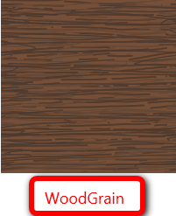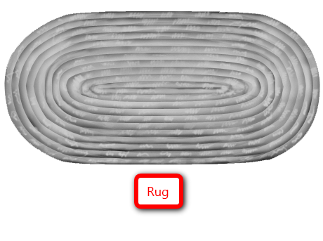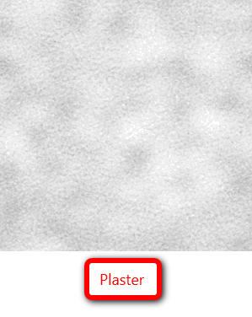

Basic Concepts of Material Editor

Materials
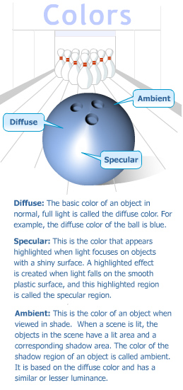
A good artist is a keen observer. Spend some time observing the objects around you. Feel the surface of the table and the texture of clothes you are wearing. Next time you take a walk in the lawn, feel the bark of trees, and look at the patterns on the leaves. You can create similar effects in 3ds Max and create realistic objects by assigning materials to them.
Color, opacity, reflection, texture, shine, smoothness, etc. are some of the attributes of a surface. Applying these to your 3D objects can help make them appear more life-like.

Color
When describing the surface of any object, we first think of its color. For example a wooden table makes you think of the color brown and grass makes you think of the color green. Let's understand the properties of color using the graphic on the right.

Reflection vs. Refraction
What happens when you switch on the lights in your room? Objects in the room reflect the light falling on them. The reflection of light is more in the case of glossy objects. Observe and analyze different surfaces. Notice that the reflected image of an object in a mirror is different from the object itself: the image appears reversed. The shape of an object changes according to the reflecting surfaces. Look at your face in the mirror. Now look at your reflection on a metal vase. Sketch this difference in your sketchpad.
Light travels in a straight path, but there are times when light bends as it travels through a different medium such as a glass or water. Let's try this out with an experiment. Place a spoon in a glass of water and observe how the spoon appears to bend when seen through water. This happens because of refraction. When light travels through a medium, the density of the medium affects the path of the light. Examples of such materials where you can observe refraction are glass, transparent polythene bags, and water.
When you create materials for objects, you need to keep these properties of light and color in mind. 3ds Max provides parameters that calculate the reflection and refraction for an object.

How are Materials Applied?
Creating a material in Material Editor does not finish your job of creating a surface for a 3D model. To finish the job you need to apply the material to the 3D model by first assigning the material to the 3D model and then aligning the maps that are in the material on the 3D model. The process of applying a material to a 3D model can be compared to dying and printing a piece of cloth. It's the application of appropriate grass material on a 3D model of a terrain that transforms it into to a lush green landscape.

Assigning a Material to a 3D Model
To assign a material to a 3D model all you need to do is select the 3D model and assign the material to it. Any later modifications in the material are updated automatically in the 3D model.

Aligning a Material on a 3D Model
After you assign a material to a 3D model, you need to align the maps in the material on the 3D model. For example if you are creating a label for a 3D model of a bottle, you will have to position the image of the label in the front of the bottle.
The process of aligning a map in a material on a 3D model is called mapping. Mapping is frequently used to align maps such as Bump, Diffuse, and Reflection on a 3D model.
To map a material on a 3D model the 3D model should have mapping coordinates. Mapping coordinates define the way maps in a material are aligned on a 3D model. These coordinates are generated by default in primitives; they have to be generated in models that are made using splines.
To generate mapping coordinates in a 3D model you apply the UVW Map modifier to the model. The generated coordinates are called UVW coordinates of the 3D model. Setting the options of the UVW Map modifier allows you to position a map in a material on a 3D model as required. Some important options of the UVW Map modifier, their description, and their effect on a 3D model are displayed.

User Interface of Material Editor

User Interface of Material Editor
Paints give form to feelings. Before painting an artist normally sets the mood by choosing the paints and brushes that are needed for the job. His art is launched with the colors on the palette in front of him. Similarly as a 3D artist, you have Material Editor to paint your dreams. In the models you created so far you used the default colors available in 3ds max. These may not represent the true colors of those objects. To make the objects look realistic 3ds max offers an interface called Material Editor. This interface gives access to different materials to be applied to an object. You can also use this interface to create new and different materials. In this section you'll learn to use the Material Editor interface. Press "M" to open Material Editor. The Material Editor window opens up, showing a matrix of six sample slots. Each sample slot displays a sample of materials or maps. You also find a series of buttons to the right on Material Editor. These buttons allow you to modify materials and the number of sample slots to be displayed. When we assign a material in the sample slot to an object, we can manipulate its parameters from the rollouts given below the Sample Slots window. You will learn about these parameters in the next few lectures. Click on View Details tab to view the Material Editor interface.

• Sample Slot: Contains a sample object on which the selected material is assigned. This helps you understand what the material looks like. By Default, the first slot is selected.
• Get Material: Allows you to pick a material from the Material/Map Browser.
• Assign Material to Selection: Assigns the material in the active sample slot to the object in the scene.
• Reset Map/Mtl Default Settings: Discards all the changes made by you and reverts to the default settings of the sample slot.
• Makes Material Copy: Allows you to create a copy of the material in the active sample slot.
• Put To Library: Allows you to save the material in a library that is open at that time.
• Show Map in Viewport: Applies 2D material or maps to an object in the Viewport.
• Go To Parent: Allows a sub material from a material or map hierarchy to move up by one level to reach the base material.
• Go Forward to Sibling: Allows you to select a map or material lying in the same level of hierarchy.
• Select by Material: Selects all objects to which the current material has been applied.
• Material/Map Navigator: Displays a hierarchy applied to an object
• Options: Opens the Material Editor Options dialog box that allows you to set custom backgrounds and manipulate the intensity of light behind sample slots.
• Make Preview: Generates a view of the animated material in the sample slot.
• Video Checks: Checks the current material for formats that are not supported by PAL and NTSC formats.
• Sample UV Tiling: Number of repeats of the map can be adjusted with UV Tiling along the U and V axes of the object.
• Background: Shows a checked background behind the material. This is generally used to display transparent materials.
• Backlight: Helps to switch on or switch off the backlight in the sample slots.
• Sample Type: Allows you to change the shape of the material in the sample slot. The sample slot has a sphere by default.

Introduction to Maps and Materials

Material vs. Maps
Now that you're familiar with the user interface of Material Editor, you'll want to know how materials are different from maps. You might have seen people using red-colored, polka-dotted silk scarves. A 3D artist will identify silk as the material and the polka dots on them as maps.
Observe the textures on the carpet and sofas at home. The material defines the appearance of the object. Certain characteristics such as shine, transparency, color, or reflected light can help us identify a material. 3ds Max allows you to change the values assigned to these characteristics. By altering these parameters you can modify the material of an object and make it appear believable. These changes are then applied to the surface of the object.
Consider an example of a polished, brown wooden table. Here brown is the diffuse color, and the polish will be defined by the glossiness parameter. But merely modifying the above parameters will not make this table look wooden. To create realistic variations apply a Wood map to the object to show the effect of grains of wood.
Maps cannot be applied to objects directly. Maps are assigned to materials that in turn are assigned to objects. Let's take the example of a plain porcelain vase. A floral pattern can be stamped on this vase to enhance its look. This floral pattern will be the map on the vase. Multiple maps can be applied to a material.
To enhance the appearance of the vase we can also give a slight raise to the leaves in the pattern. This creates bumps on the material.
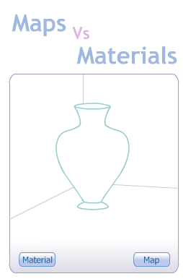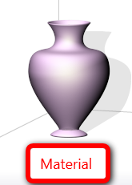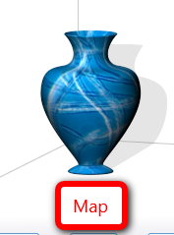

Types of Maps
Maps are divided into the following types in 3ds Max:
- 2D Maps: These are images applied to the surface of an object. The best example of a 2D map is a bitmap. Image files with extensions jpg, tiff, bmp, etc. are examples of bitmaps. Make sure you use a high resolution (size) bitmap if your camera is zooming in on an object, as this will avoid pixelation of the map and a low-resolution bitmap if the object is placed at a distance from the camera.
- 3D Maps: When a bark of a tree is cut, the grains of wood can be seen running throughout the length of the cut. You can use 3D maps to bring out this effect. Similarly cutting through the mesh while creating a Boolean will reveal the map even on the insides of the object. These maps are generated throughout the volume of the object, and they become part of the geometry. All 3D maps are Procedural Maps as they are generated mathematically. An advantage of using these maps is that the quality of the image does not deteriorate as the camera zooms in on the image.
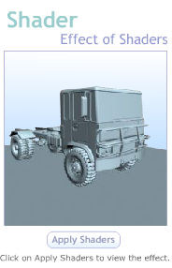
- Compositor Maps: These maps are used to merge two or more maps by using masking techniques that show or hide the various layers of maps. For example, this map is used to reveal a wall through peeled wallpaper.
- Color Modifier Map: Have you ever seen the changing colors of a chameleon? Just like the chameleon acquires the color of the surface it steps on, an existing color of the map can be overlaid with other maps with the use of these map modifiers. These maps work on pixels of the material to bring out the color change on it. Output, RGB Tint, and Vertex Color are three methods used to modify the color of the material.

Shaders
As children you played with toy cars. Let's look at how those cars differ from real automobiles. The surface of a real car is glossier than that of a toy car. This difference is due to the different shaders used on these two objects.
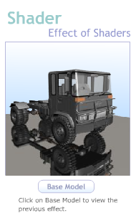
Shaders are used to impart different looks to a surface. The shader on a material decides how light interacts with that material. The way in which light reflects from a fabric is different from the way it does from plastic. Highlights on a fabric are diffused whereas on plastic they are sharp. Due to these differences it is easy to identify the materials to be used for these objects. Now let's take another example of objects made from metal and glass. The difference between their highlights would be subtle. Studying these highlights helps you bring out the look you are trying to replicate.
In 3ds Max, shaders define the way a surface is affected by light. You can choose a shader from the drop-down list in the Basic Shader Parameter rollout. Although most shaders have several items such as ambient, diffuse, opacity, self-illumination, specular and highlights in common, other shaders have some parameters that are specific to them.

Types of Shaders
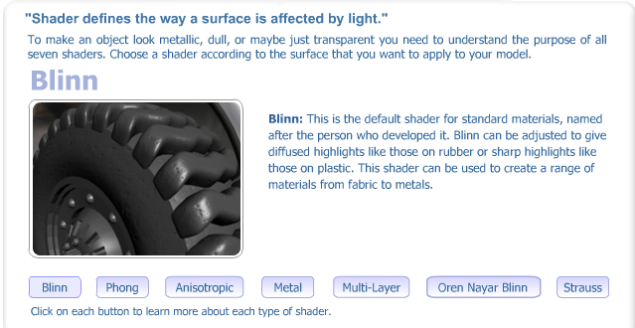
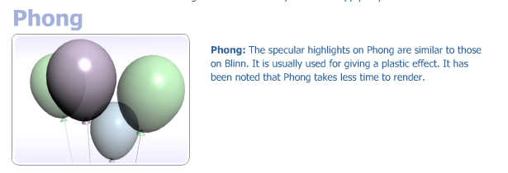
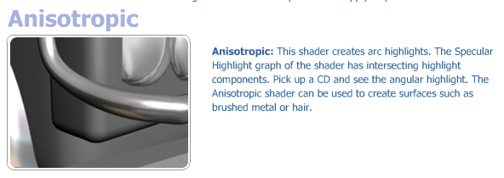

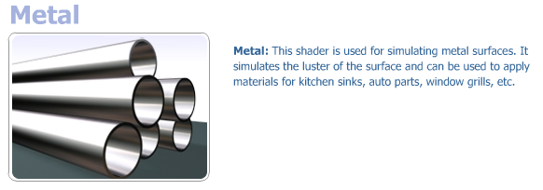
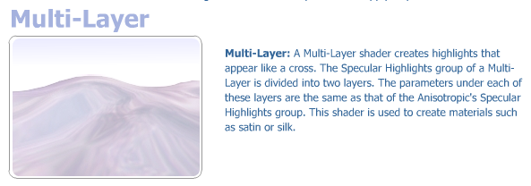
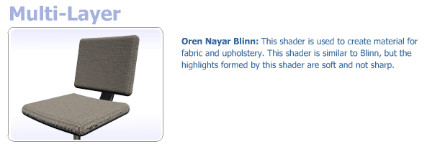
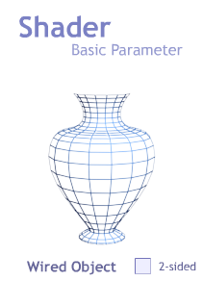
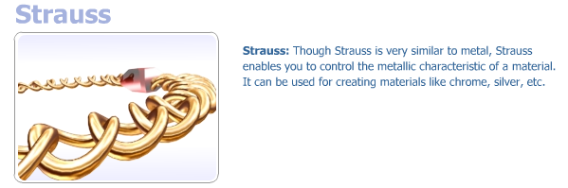

Using Standard Materials
Most artists strive to make their objects look believable, just like the way you intend to add textures to the objects you have created to make them appear realistic. In this lecture you'll learn to use Standard Materials to assign materials to objects.
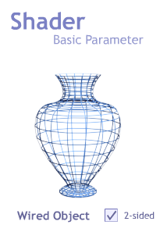
Standard Material is the default material that appears in the sample slots of Material Editor. Material Editor provides six sample slots by default. You can activate a sample slot by clicking on it. An active sample slot has a white border around it. If the material in a sample slot is assigned to an object in the scene, it can be identified by the white triangles at the four corners of the slot. Materials used in a scene are considered "hot," while materials not used in a scene are considered "cold." A copied material is considered "warm." Changes made to a hot material are reflected in the scene automatically.
Equipped with this knowledge, let's look at some of the parameters of Standard Materials.
Shader Basic Parameters Rollout
- Shader Drop-Down List: Contains a list of shaders discussed in the previous session. The default shader for the Standard Material is Blinn.
- Wire: When this option is checked, the object in the sample slot is converted to a wired framework.
- 2-sided: When this option is checked, the material or map in the active sample slot is assigned to both sides of an object.

Shader Basic Parameters
Because the default shader is Blinn, the name of the parameter rollout will be Blinn Basic Parameter. Based on the shader selected you can set the ambient, specular, and diffuse properties of the material. In addition to these properties some widely used parameters are as follows:
- Self-Illumination: Some objects such as light bulbs can have an inherent glow that can be shown by increasing the amount of Self-Illumination. You can also choose the color of light emitted.
- Opacity: Increase the value assigned to this field to make an object opaque.
When you want to show a wooden table or a brick wall in the swimming pool, you can assign maps to Standard Materials. Color, opacity, and smoothness of a surface can be changed using maps. The Maps rollout allows you to apply maps to materials.

Define Map Channels
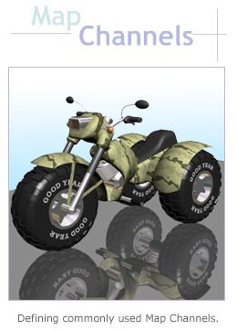
So far we have seen how to use materials to make objects appear realistic, but when you need to create patterns on these materials, you'll use maps. This week you'll learn to create some patterns on materials by using Map Channels and the Material/Map hierarchy. You'll also learn to load and save Material libraries.
Take a look at the model of the motorbike to your right. This was created in 3ds Max. Notice the texture on the tires and the reflective surface of the motorbike. See how well the transparency of the indicator is portrayed. In this session we'll discuss some of the commonly used Map Channels.

Map Channels
As you work with materials, you'll find the need to add more than one map to an object. For example while modeling the motorbike in the above example, the artist has applied maps to show bumpy surfaces, transparencies, and reflection. Depending on the shaders selected, 3ds Max offers a set of Map Channels that can be set as you require. You can add a touch of realism to the objects by setting appropriate maps to these Map Channels.
To access Map Channels click on the Map rollout in the Material Editor window. You'll see a list of Map Channels, each of which can take a value indicating the amount of map assigned to the material.
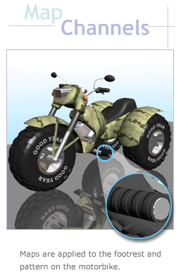
Let's take a look at some Map Channels that can be assigned to the properties of a material.
- Diffuse: This is the surface color of an object under normal daylight. In our example of the motorbike the apparent surface color is pale green. Diffuse is one of the most important qualities of a material because it determines the color of an object. If the object has a plain color, then the color swatch can be manipulated. But when there are patterns on the surface like the one shown on the motorbike, apply a map.
- Bump: Bump maps are generally used to create relief on an object. A bump map gives a raised or depressed effect to an object without affecting the geometry. The motorbike, for example, has some bumps on its footrest. Lighter areas of the map will appear raised, while darker regions appear depressed. The degree of bump can be adjusted using the Amount drop-down list of the Bump map.
Tip: Usually a single map is used for both Bump and Diffuse maps to give an object a realistic effect.
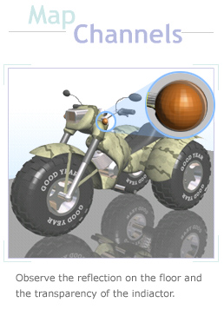
- Opacity: Look at the transparency of the indicators on the motorbike. This can be created by manipulating the opacity of the material. By applying a map for opacity, a portion of the material can be made either opaque or transparent. Decreasing the amount of opacity makes the map transparent in that particular area. In 3ds Max black is considered transparent and white is considered opaque. Thus, on applying a map to this parameter all the black areas are transparent, and all the white areas are opaque.
- Reflection: Every surface reflects light from its surroundings. Objects like glass, metal, and other polished surfaces have reflective properties. The quality of reflection will be based on an object's reflective property.
Look at the reflection of the motorbike falling on the floor. Since the floor is a polished surface, you can see a clear reflection of the motorbike. You can achieve this effect by adding Flat/Mirror maps on the Reflection map. You'll learn more about Flat/Mirror maps later in this week. You can manipulate the intensity of reflection by adjusting the Diffuse color, since reflection is directly proportional to the amount of diffuse color.
Note: These maps are available under the Map rollout of the Material Editor.

Material Library
Similar to the manner in which a library of books and periodicals is organized, 3ds Max maintains a library of materials classified in a variety of categories. Material Library allows you to store and access a variety of materials. Material Library can be viewed from the Material/Map Browser.
The default collection of materials is stored under the matlib folder in the 3ds Max directory. The collection of materials and maps under the matlib folder is displayed by default when the Material/Map Browser is opened. Some of the commonly used maps and materials provided by 3ds Max are Sky, Ground, Concrete, and Wood.
The materials created for a scene can be reused in another scene by saving them in your Material Library and recalling when needed. In the next section we'll see how to load, create, save, and merge materials.

Material/Map Hierarchy
When you want to enhance the surface of a clay model you first coat it with an adhesive sealer, then different coats of primers are added before additional topcoats are sprayed. Similarly, when you use Material Editor, there are chances that you'll need to assign more than one map on a material. This leads to a hierarchy being developed within Material Editor. Typically when a map is added to a material, it becomes a sub material. You can add more than one map to the base material. Compound materials such as Blend or Composite, allow you to add more than one material on a base material. Each sub material can further have other maps applied to it. This is known as the Material/Map hierarchy. In the Material/Map hierarchy when there is an increase in the amount of sub material, it becomes difficult to trace a specific map or material. This is when we view the hierarchy through the Material/Map Navigator icon. Click on View Details tab to view the Material/Map Navigator.

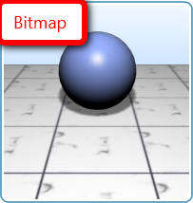
Using Maps
The next time you go for a drive look at the highway. Notice the lampposts that fly past you at regular intervals on the road. Look at the sign that reminds people to drive slowly. Look at the pavement running along the road. Now let's take a look at the maps that can be used to simulate such effects.
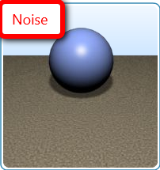
Bitmap: Bitmaps are 2D images made up of a matrix of pixels. Whenever you have to apply an image on a surface, you use bitmaps. For our example you can create a "Drive Slow" image and save it as a bitmap. You can then apply it as a map for the diffuse color. While using bitmaps be cautious, since they add to the file size. As the number of pixels in a bitmap increases, the file size increases.
Noise: The Noise map generates randomness in the parameter applied. A Noise map makes use of two colors or materials. One of these colors is the base color on which the other color is randomized. Take a look at the star lit sky at night. You can consider stars as random bumps that appear on the sky's surface. A Noise map can be applied to achieve this effect in the Bump map channel.
The Noise parameter rollout offers Regular, Fractal, and Turbulence as the three types of Noise maps. Two color swatches in the Noise rollout allow you to choose two colors to depict the noise. For example, a stone will have a black and white bump map. You can choose the Regular Noise map to show minor disturbances on the surface and assign it to the object.
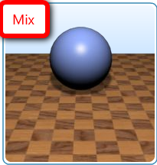
- Mix: Use Mix maps to combine two colors or materials to be applied on a single surface. The Mix map uses a Mix Amount value to blend both these colors. We can create the pavement of a highway by using Mix map on the Diffuse color. Mix Map will use two colors. Choose one of them to be dark gray. For the second color you can choose "gryDirt2.jpg" from the collection of bitmaps. This bitmap will be revealed from the dark gray color of the road. Define the amount of the second map that should be revealed using the Mixing Amount option from the Map rollout. The mixing curve helps in providing a transition in the manner of the mix between the maps.
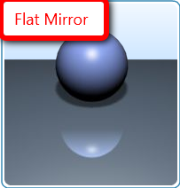
- Flat Mirror and Reflect/Refract: If you were to place a phone and a porcelain cup next to each other, you would notice the reflection of the cup on the phone. Surfaces always reflect light from their surroundings. A shiny metallic surface will provide true reflection. 3ds Max offers Reflect/Refract maps and Flat Mirror Reflection maps for simulating reflection.
Flat Mirrors give high quality reflection. Use Flat Mirror reflection to simulate reflection like a mirror or a flat glossy surface. Because Flat Mirror maps give quality reflection, they take time to render. Although Flat Mirror gives good reflections, they cannot be applied to all objects. Flat Mirrors can be applied only on flat surfaces or planar objects and not on cylindrical or spherical objects.
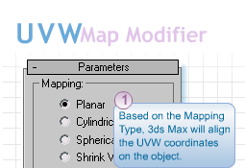
Reflections from Reflect/Refract maps may not be as realistic as the effects brought about by Flat Mirror or RayTrace maps, but the advantage of using a Reflection/Refraction map is that it helps in faster rendering. Reflection Maps work on World Coordinate Systems and hence the reflections change as the object's position changes. For example, if you pick a candle stand and happen to rotate it under light, you'll see the reflection of light move.

Using UVW Map Modifier
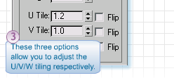
When you want to align a map on a surface, it is best to use UVW Map modifier. This modifier helps place the map on the object as required. The UVW Map modifier projects 2D maps on an object according to the UVW mapping coordinates. Similar to XYZ coordinates for objects in 3D space, UVW are the mapping coordinates on the surface of an object. Mapping coordinates define the manner of placement of a map on an object.
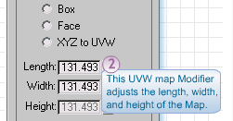
The parameters of the UVW Map modifier allows you to perform the following:
- You can apply any of the seven mapping coordinates shown in the Parameter rollout to a surface.
- You can adjust the size and dimensions of the mapping types.
- When there are repeating maps, you can give a tiling effect.
- You can align maps based on the mapping coordinates of the object.

By default all objects contain UVW mapping coordinates. But when a Boolean is used or the object is collapsed to an Editable Mesh, the object loses its coordinates. In such cases the UVW Map modifier can be applied explicitly.

Tip: It is necessary to use the UVW Map modifier when a Boolean action has been conducted or the mesh has been converted to an Editable Mesh.

Summary
This week you have learned about what is known in the industry as texturing. You have learned the basics of materials and textures and how they affect the appearance of the geometry that you have created. You have also studied UV maps and texturing options.
Next week, you will see more on lighting. The lights on a scene can affect the way a texture is perceived by the viewer, since light is what will allow us to read the color.
Proceed to complete the exercises on the Assignments section to put into practice the concepts learned in this week’s lectures and Reading Assignments.

Assignment 1: Practice Exercise
This week, you're seeing how to apply materials and maps to the geometry in your scene. Complete the exercises listed on the Reading and Assignments section. By Tuesday, February 2, 2010, write a note on the areas listed below and post it to the Discussion Area along with the jpgs of the rendered exercises. Also by Tuesday, February 2, 2010, save your 3ds Max files for each of the exercises to the W4: Assignment 1 Dropbox.
Respond to the following self-evaluation areas:
- Which lesson do you find more valuable?
- Which problems did you encounter through the process and how you fixed the problem?
- List and provide an explanation of at least two concepts that you learned this week.
- Explain how you can apply the concepts included on this exercise to your final project (see Assignments 2 and 3 this week for more details on the final assignment).
By the end of the week, respond to at least two other student’s postings. Comment on their achievements and their findings included on their note. Post your responses to the Discussion Area.
Assignment 1 Grading Criteria | Maximum Points
Successfully completed all practice exercises listed in the Reading and Assignments section. | 4
Included notes on the learning experience. | 4
Participated in class discussions. | 4
Total: | 12
For assistance with any problems you may have when completing this assignment—OR—to offer your assistance to classmates, please use the Problems and Solutions Discussion area located through the left side navigation link.

Assignment 2: Final Project - Creating and Applying Materials
Create materials for each of the objects on your scene. Consider the quality of the surfaces and remember that you can use the same material in more than one surface if necessary. Apply these materials to the models in the scene.
Don’t include textures just yet. Your goal is to have the surface properties, such as shine and transparency setup correctly for your objects. Don’t forget to rename your materials to significant names in the Material Editor. This will be very helpful on the next assignment, where you will apply maps.
Save your work file as LastName_W4_A2.max and render your progress as LastName_W4_A2.jpg. Post the final 3ds Max file to the W4: Assignment 2 Dropbox and the rendered .jpg file to this Discussion Area by Thursday, February 4, 2010.
Along with the rendered jpg(s) post a self-review using the following questions:
- Did you achieve your texturing goals?
- Which areas of the project are you satisfied with?
- Which areas of the project do you believe you could improve?
- Which difficulties did you find during the texturing process? How did you solve these difficulties (which solutions worked for you)?
Before the end of the week, critique the work posted by at east two other classmates. Discuss all of the following:
- Which areas were most successful? Discuss the application of this week’s concepts to the work.
- Which areas could use improvements?
- Provide ideas or tips on how to improve these areas based on what you have learned this week.
Assignment 2 Grading Criteria | Maximum Points
All elements on the scene have materials applied that correspond to the surface properties. | 5
Instructions were followed with output delivered in the specified file formats and required naming conventions. | 4
Student responded thoughtfully to self-critique questions. | 5
Student critiqued at least two other students work based on the critique guidelines. | 4
Total: | 18
For assistance with any problems you may have when completing this assignment—OR—to offer your assistance to classmates, please use the Problems and Solutions Discussion area located through the left side navigation link.
W4A2
Create materials all of the items in your scene. Post your work here.

Assignment 3: Final Project - Creating and Applying Material Maps
Look back at your scene with the materials applied. The scene has the base colors that it will have, but it doesn’t have any texture or patterns applied to it. Edit the materials to create maps on objects to create patterns or texture bump maps. For example, apply a bump map to the walls to create a stucco effect, or create a wood material to simulate the wood surface of a coffee table.
While you can apply maps to as many objects as you want, verify that you have at least 4 maps applied to your scene. You might need to apply an UVW Map or Unwrap modifier to objects that have problems adjusting the map to the surface. Verify that your scene materials look proportionate to the scene by adjusting “U and V tiling.”
Save your work file as LastName_W4_A3.max. Render your scene and rename the render LastName_W4_A3.jpg. Post the final 3ds Max file to the W4: Assignment 3 Dropbox and the rendered .jpg file to this Discussion Area by Saturday, February 6, 2010.
Along with the rendered jpg(s) post a self-review using the following questions:
- Did you achieve your texturing goals?
- Which areas of the project are you satisfied with?
- Which areas of the project do you believe you could improve?
- Which difficulties did you find during the texturing process? How did you solve these difficulties (which solutions worked for you)?
Before the end of the week, critique the work posted by at east two other classmates. Discuss all of the following:
- Which areas were most successful? Discuss the application of this week’s concepts to the work.
- Which areas could use improvements?
- Provide ideas or tips on how to improve these areas based on what you have learned this week.
Assignment 3 Grading Criteria | Maximum Points
All elements on the scene have materials applied that correspond to the surface properties. | 4
Textured elements on the scene show proportions, texture scale, and placement that is accurate with the surface properties. | 10
Instructions were followed with output delivered in the specified file formats and required naming conventions. | 4
Student responded thoughtfully to self-critique questions. | 5
Student critiqued at least two other students work based on the critique guidelines. | 4
Total: | 27
For assistance with any problems you may have when completing this assignment—OR—to offer your assistance to classmates, please use the Problems and Solutions Discussion area located through the left side navigation link.
W4A3
Create textures for all of the items in your scene. Post your work here.

Did you achieve your texturing goals?

Which areas of the project are you satisfied with?

Which areas of the project do you believe you could improve?

Which difficulties did you find during the texturing process? How did you solve these difficulties (which solutions worked for you)?

